**Cloud Computing**

**UE19CS352**

**6th Semester, Academic Year 2021-22**

Assignment #: 3 DynamoDB

Date: 14/3/2022

|  |  |  |
| --- | --- | --- |
| Name :  SUMUKH RAJU BHAT | SRN :  PES1UG19CS519 | Section :  H |

pes1ug19cs519_1a:

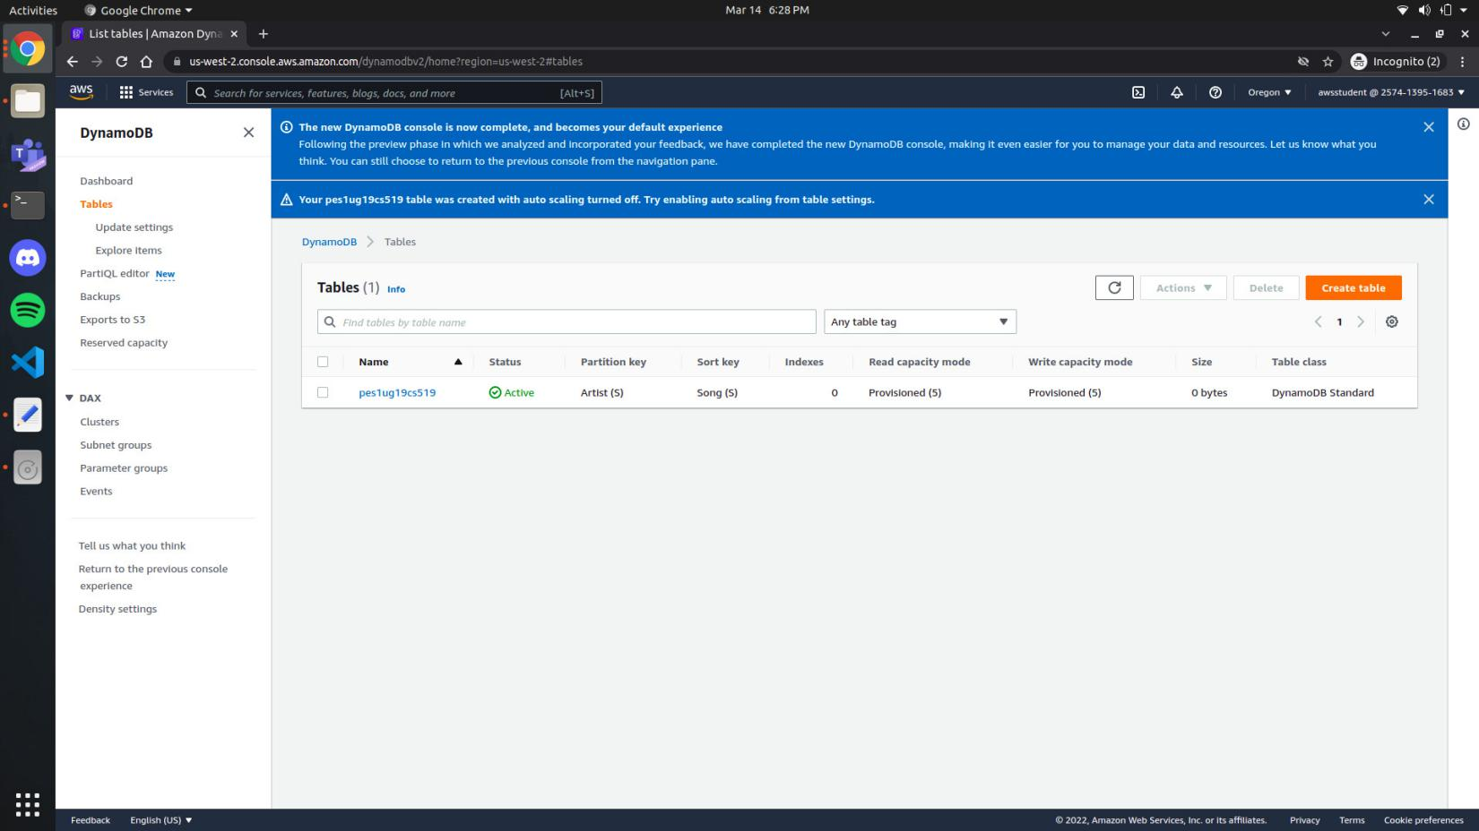

pes1ug19cs519_2a:

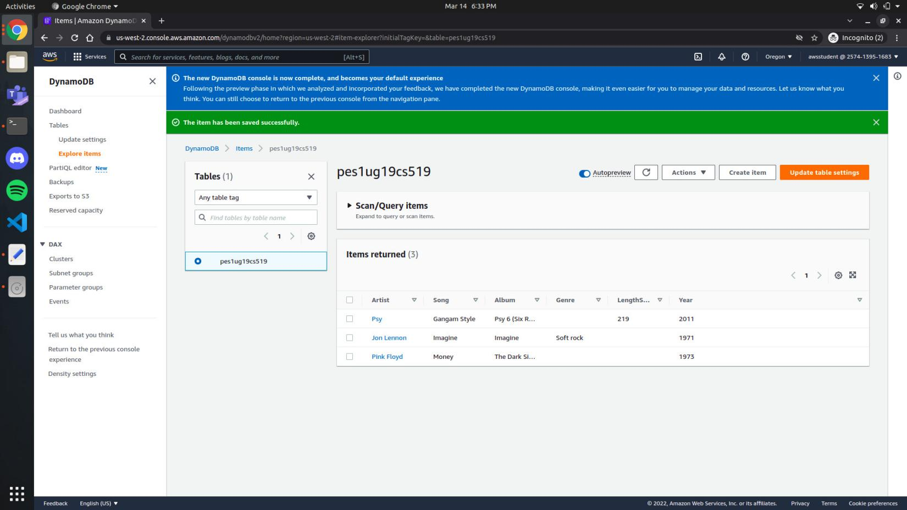

pes1ug19cs519_3a:

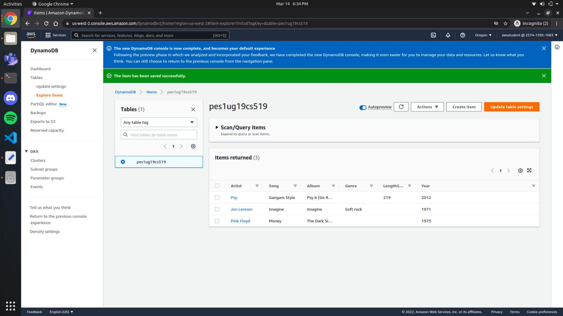

pes1ug19cs519_4a:

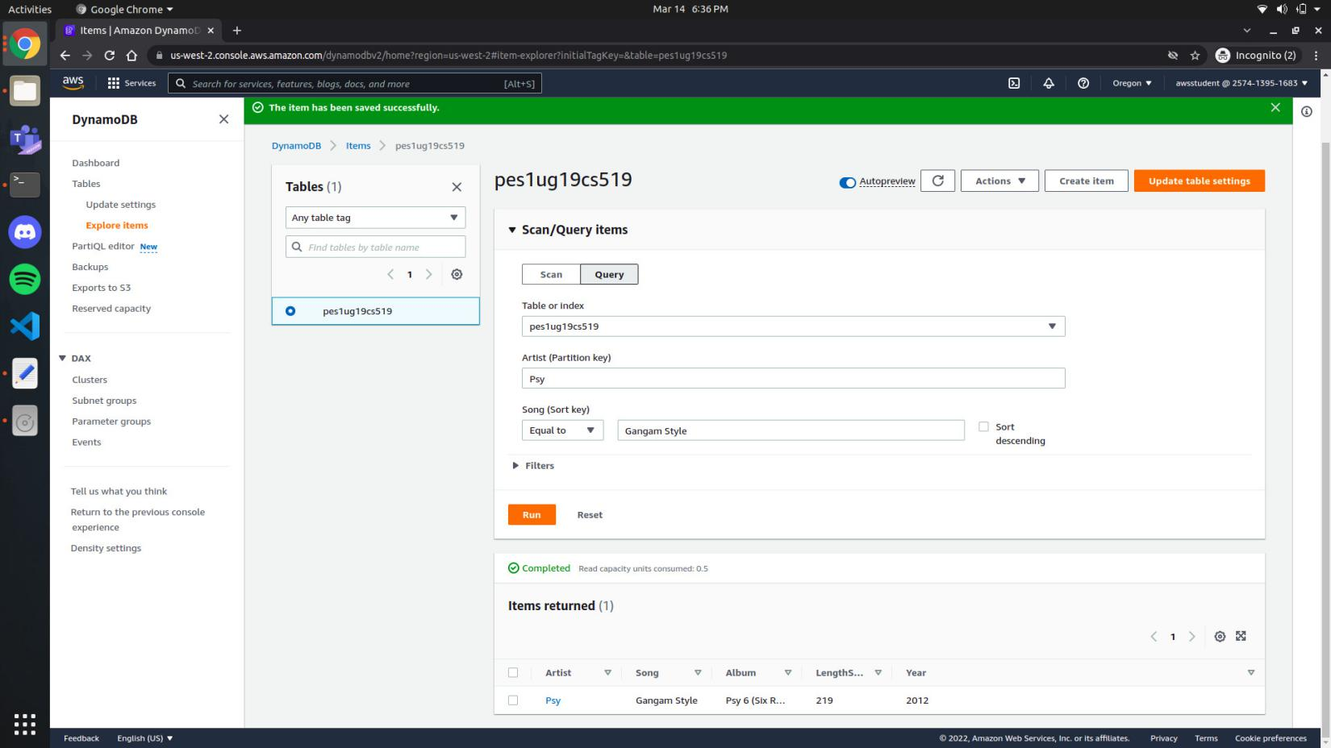

pes1ug19cs519_4b:

